2JSM
Sequence (5’ to 3’) | $ϵ_{260nm} (M^{−1}cm^{−1})$ | DOI
TAGGGTTAGGGTTAGGGTTAGGG | 236500 | 10.1093/nar/gkm706

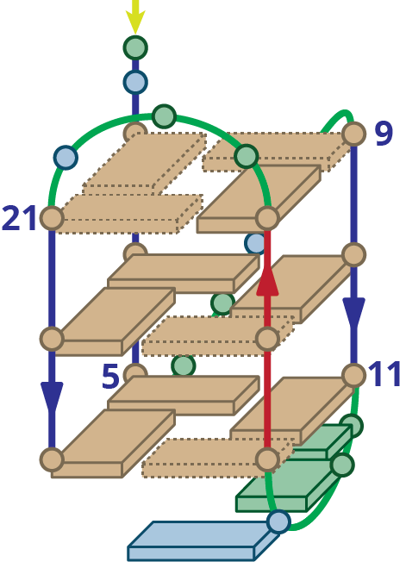
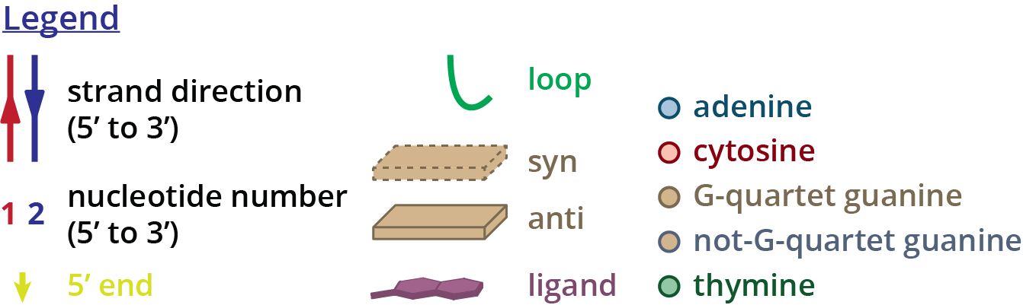
Structure diagram of 2JSM

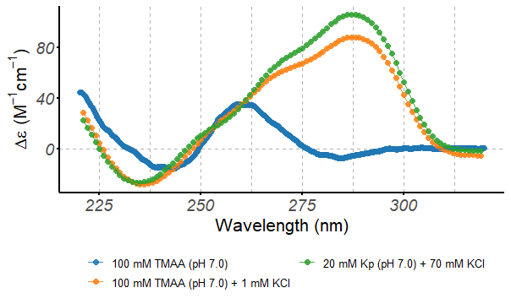
Circular dichroism spectra of the 2JSM oligonucleotide (10 µM), acquired at 25°C in 0.4-cm path-length cuvettes

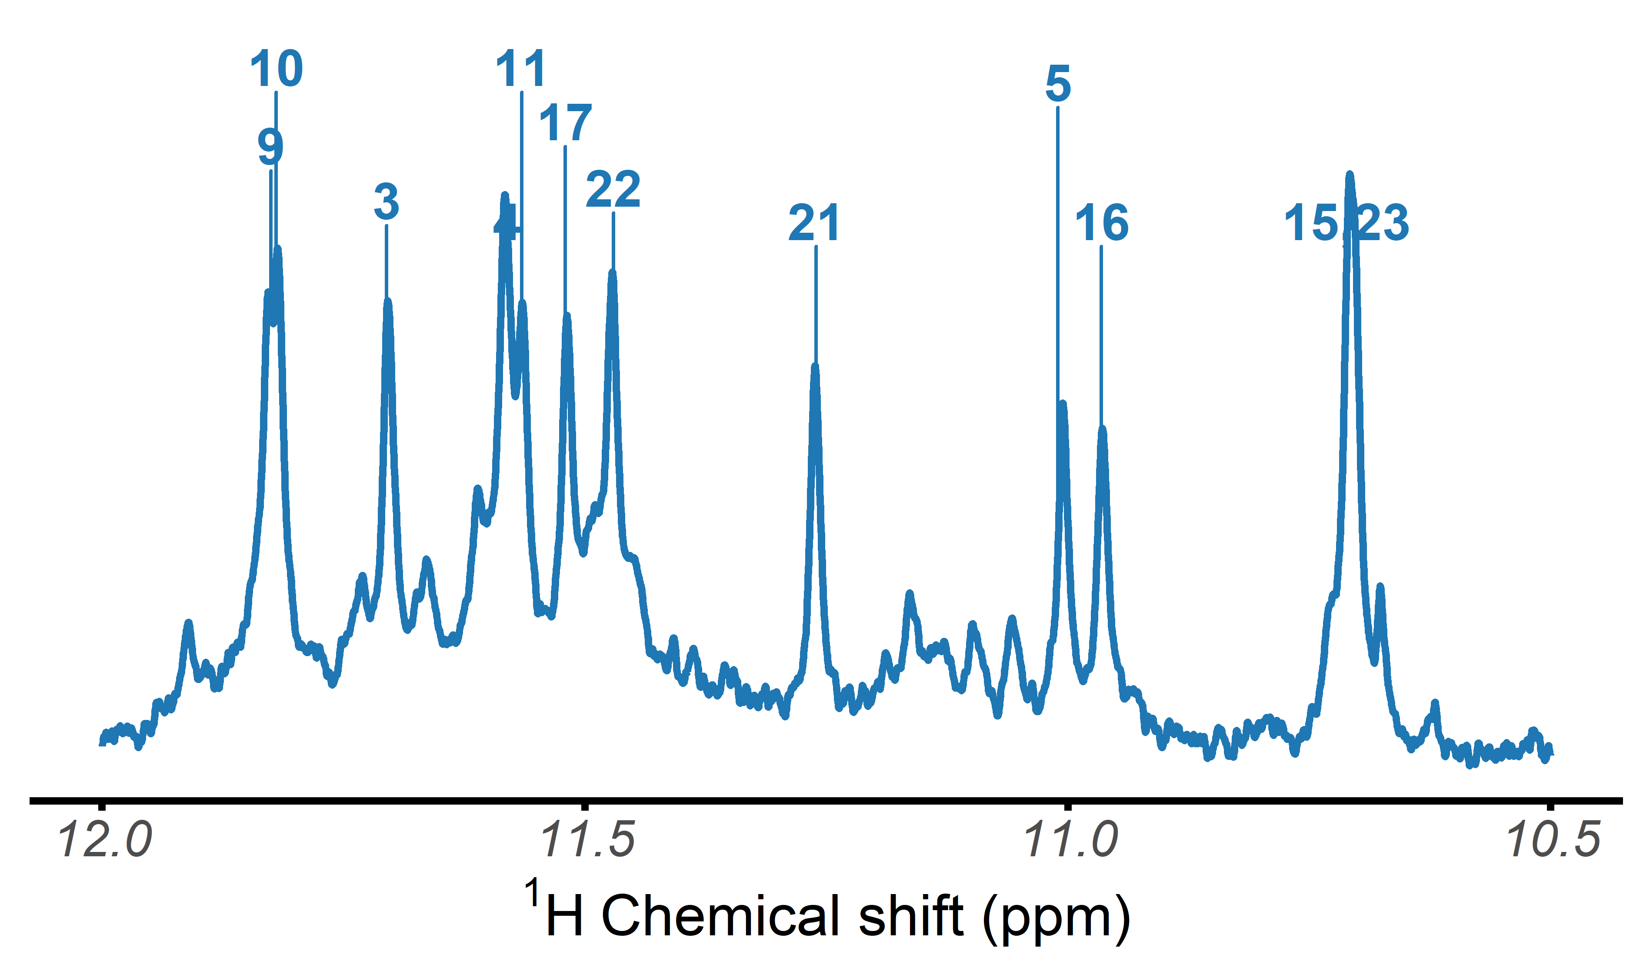
$​^{1}$H-NMR spectrum of the 2JSM oligonucleotide, acquired at 25°C in 100 mM TMAA (pH 7.0) + 1 mM KCl

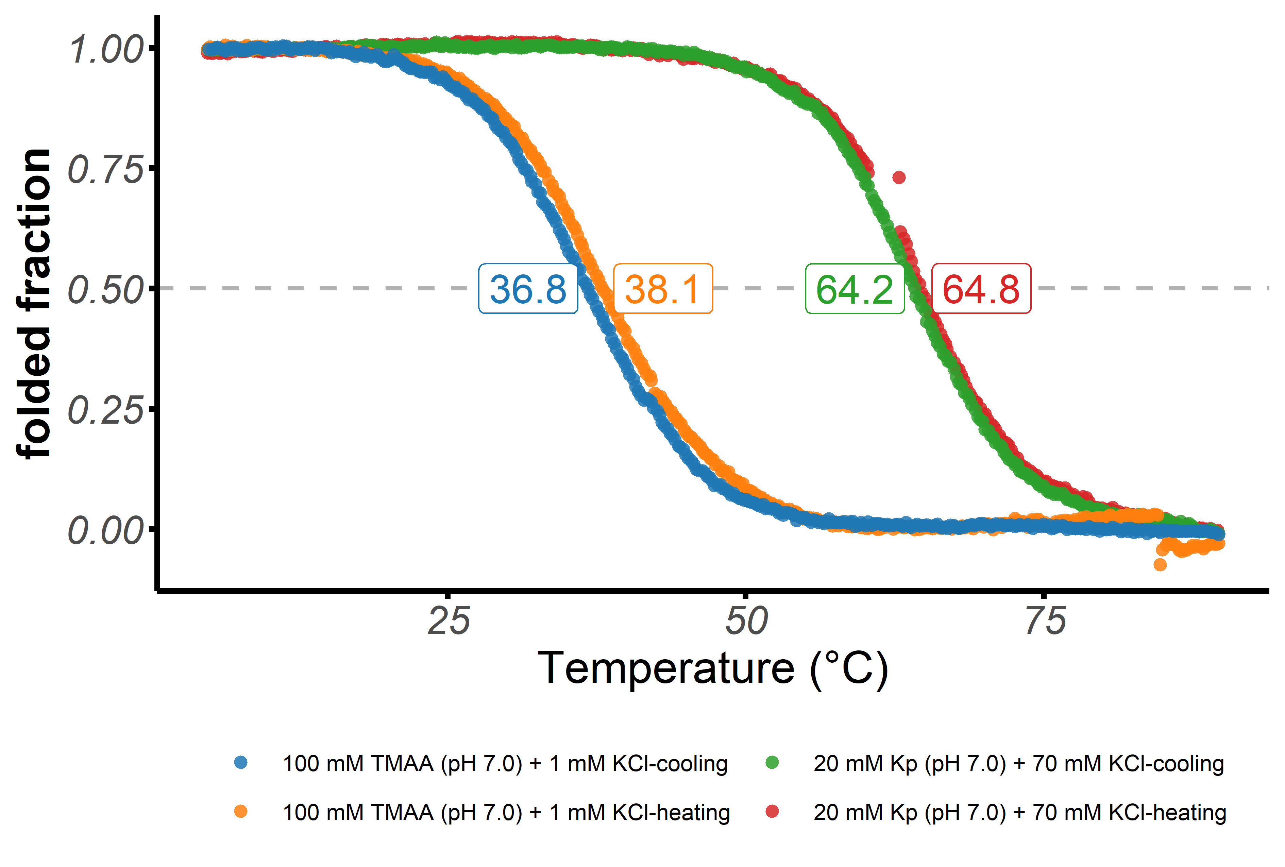
Folded fraction of the 2JSM oligonucleotide as a function of temperature, determined by UV-melting ($λ$ = 295 nm)

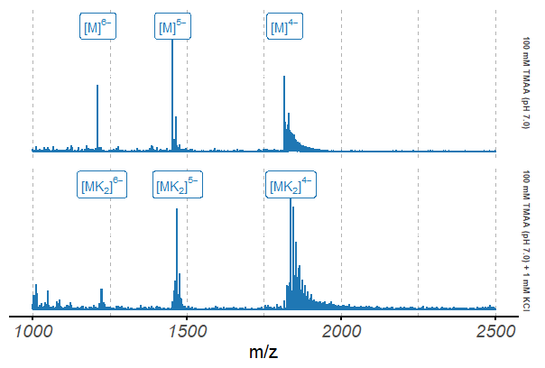
Native ESI-MS spectra of the 2JSM oligonucleotide (10 µM)

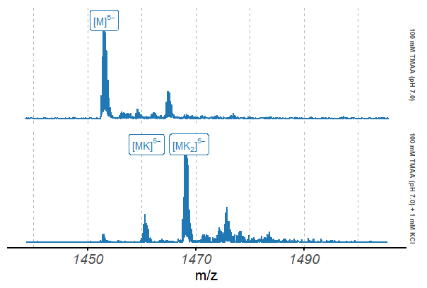
Native ESI-MS spectra of the 2JSM oligonucleotide (10 µM), focused on the 5$​^{−}$ charge state

